**ASSIGNMENT-1**

Create a blog or website using Blogspot and WordPress .Customize the theme design and post new article with 500 words.

|  |  |
| --- | --- |
| NAME | Bharath Srikanth.P |
| NM ID | 1DB94440FC7FB40AE9E49813F967D58A |
| ASSIGNMENT 1 | Create a blog or website using Blogspot and WordPress |

**Blog page link:**

https://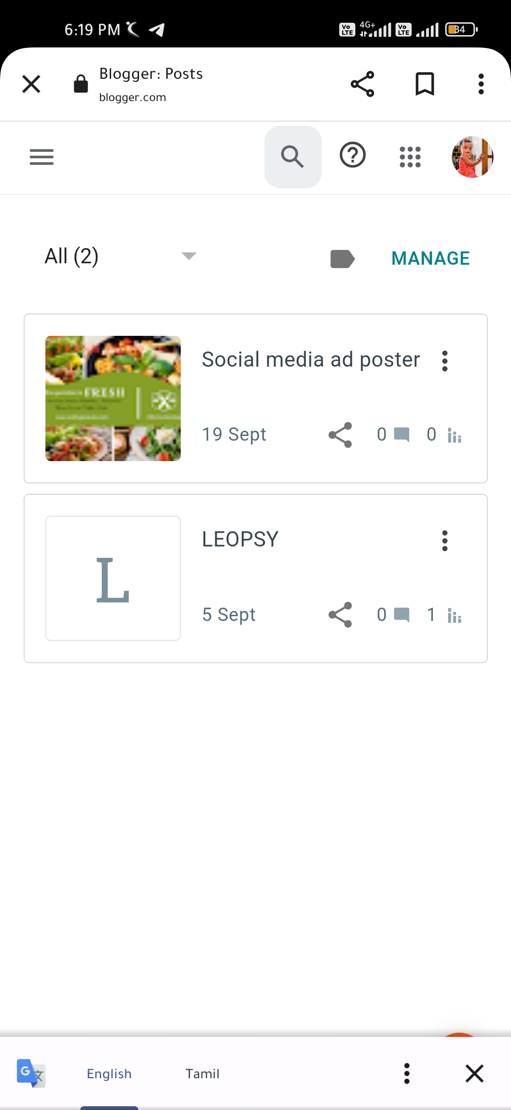www.blogger.com/blog/posts/8993326665400245507